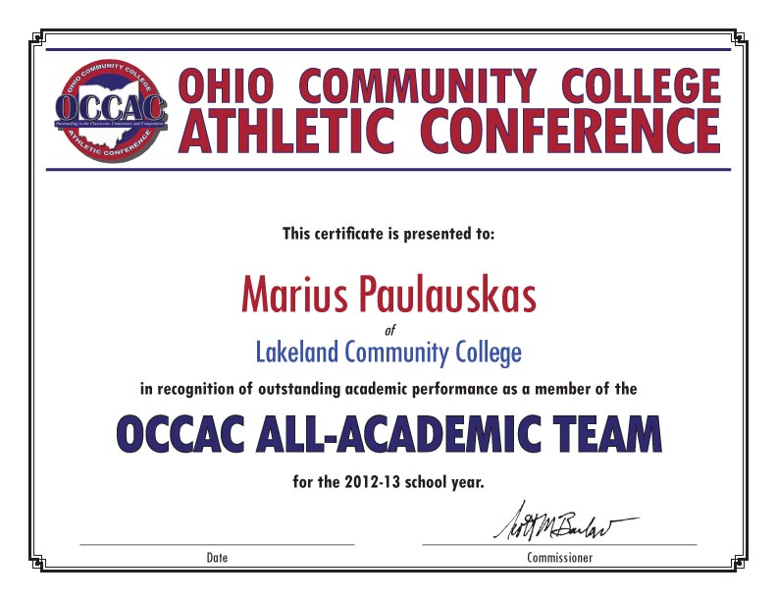

**OCCAC PLAYER OF THE WEEK WEEK**

**in the sport of [insert sport]**

**in recognition of outstanding athletic performance as the**

*of*

college

name

Date